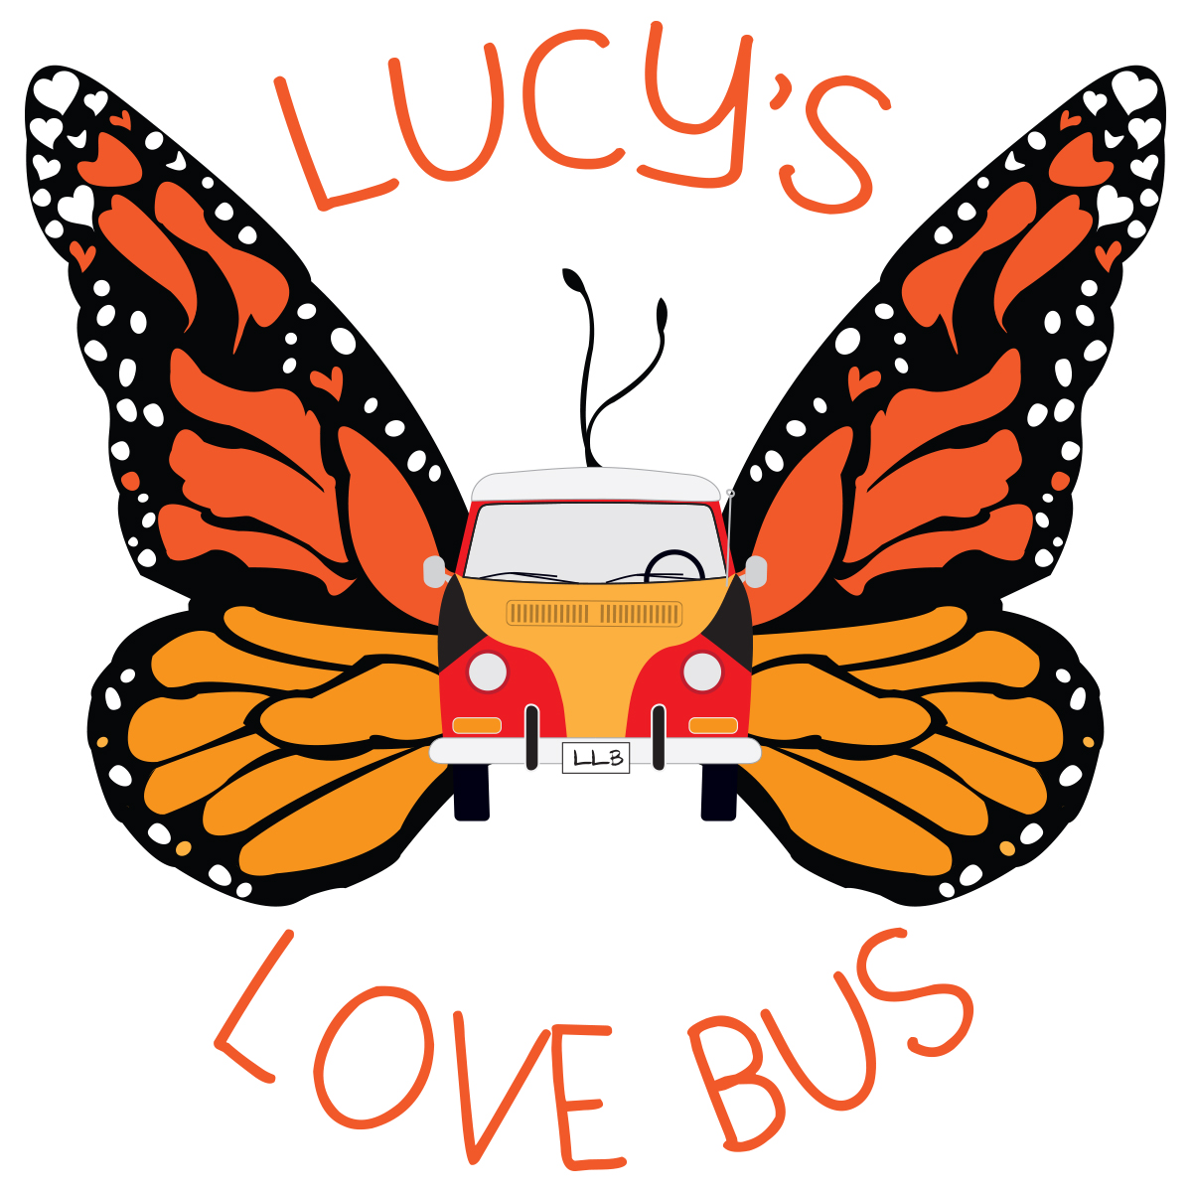

Lucy’s Love Bus

Delivering Comfort... Until A Cure.

Lucy’s Children Application – Funding for Integrative Therapies

The Mission

Lucy’s Love Bus™ seeks to deliver comfort and quality of life to pediatric cancer patients by providing funds and referrals for free integrative therapies. We believe integrative therapies can help offset the rigors of traditional cancer treatment by gently supporting the child’s emotional, physical, and spiritual wellbeing.

We serve children who were diagnosed with cancer before the age of 21 either currently undergoing treatment or suffering from late effects, who are living in or being treated in New England.

We offer an initial funding award of $1,000. Twelve months after the initial funding award and every 12 months thereafter, your child will be eligible for $500 if needed and as we have it available.

Child’s name: ________________________________________________

Date of Birth: ________________________________________________

Patient’s pronouns ☐ He/him/his ☐She/her/hers ☐They/them/theirs ☐ Other: __________

Home Address: _____________________________________________________

_____________________________________________________

Parent/Guardian Name: ____________________________________________________

Relationship to child (circle): Mother Father Other: ______________________

☐ I am the parent/guardian, please contact me at the below information.

☐ I am the patient over the age of 18, please contact me directly at the below information.

Phone number with area code: __________________________________ ☐ Cell ☐ Home

Email: _____________________________________________________

Preferred method of communication?
☐ Text my CELL ☐ Call my CELL ☐ HOME PHONE ☐ EMAIL

Child’s Cancer Diagnosis: _______________________________________________
Date of Diagnosis: ________________________
Hospital: _______________________________________________

Primary Oncologist: _______________________________________________

Oncologist phone/email: _______________________________________________

Name of social worker: _______________________________________________

Social worker phone/email: _______________________________________________

Notes and comments: _____________________________________________________
_____________________________________________________
_____________________________________________________
What type of integrative therapy or service/s is your child interested in receiving?
Please choose up to 3 therapies and number them in order of interest.

Massage Acupuncture/acupressure Therapeutic horseback riding Swimming lessons
Chiropractic care Art therapy Aromatherapy/Essential Oils Nutritional counseling Reiki/Tong Ren/QiGong/Other Energy Work Music therapy Meditation Yoga
Healthcare Advocacy Reflexology Child life Craniosacral therapy Gymnastics or Dance
Naturopathy/herbal supplements Fertility Preservation Gym membership/personal training

If your child is already working with a practitioner, please list their contact information below!

Business/contact name: ______________________________________________

Telephone: ______________________________________________

Email: ______________________________________________

If you have not identified resources in your area, we are happy to connect you to wonderful providers who have been screened and added to our network of resources.

Names/ages of siblings: _____________________________________________________
_____________________________________________________
Through our Sajni’s Siblings program, we pay for siblings to participate in integrative therapies together, or pay for them to have a separate integrative therapies (restrictions apply).
☐ Check here to learn more about this program.

Demographic information

This optional information is collected so that we can accurately measure the impact of our services.

This information is confidential and will only be shared as a dataset, with no specific tie of your submitted data to your name/personal information. Thank you for helping us collect this important information.

Household income bracket:

☐ Less than $20,000 ☐ $20,000 to $34,999 ☐ $35,000 to $49,999

☐ $50,000 to $74,999 ☐ $75,000 to $99,999 ☐ Over $100,000

Child’s Ethnicity (select all that apply)

☐ Asian or Asian American

☐ Black or African American

☐ Caucasian or white

☐ Hispanic, Latinx, or Spanish Origin

☐ Middle Eastern or North African

☐ Native American, American Indian, or Alaska Native

☐ Native Hawaiian or Pacific Islander

☐ Mixed

☐ Different identity: please specify _______________
Please check the corresponding box(es) below if the child for whom you are applying identifies as/with:
☐ non-binary, genderqueer, or third gender

☐ LGBTQIA+
☐ having a disability and/or disabled
☐ neurodivergent

Please check the corresponding box(es) below if you (the parent/guardian) identify as/with:
☐ non-binary, genderqueer, or third gender

☐ LGBTQIA+
☐ having a disability and/or disabled
☐ neurodivergent
☐ Veteran or Active Duty Military

Our Process

Once we receive the completed application for your child, we will confirm receipt and discuss current options for funding. Please allow up to two weeks for initial contact after you submit your application.

We will reach out via your indicated preferred contact method to discuss funding availability.
- We must pay a provider directly; we cannot pay or reimburse families for services already received.
- Funding is awarded on an as-needed basis (not as an annual amount). Funding does not expire.
- We pride ourselves on matching your child with the best practitioner(s) to meet their needs. While we require proof of applicable certifications and licenses from the practitioners we work with, we require that you stay with your child throughout their appointment to ensure their safety and comfort.

By accepting funding from Lucy’s Love Bus, you agree to participate in one brief annual survey so that we can assess our programs and secure more funding for children with cancer. This survey is conducted by email or phone, consists of 5 questions, and takes less than 5 minutes to complete.

We appreciate your support in capturing the benefits of our work together. Thank you!

Lucy’s Love Bus has provided this material for your information. It is not intended to substitute for the medical expertise and advice of your primary health care provider.

Guardian Signature: ___________________________________________ Date: _____________

Please let us know how you heard about us:

Our social worker Our doctor Friend/Family Internet search Social media Other: ___________________

Comments or questions:
_______________________________________________________________________________________________________________________________________________________________________________________________________________________________________________________________
Application Checklist:
- Signed and completed “Application Intake Form” (3 pages)
- “HIPAA Notice of Privacy Policies”, “Authorization to Use or Disclose My Health Information”, “Release and Agreement”
- Medical Permission form signed by child’s oncologist, NP, or attending physician

Submit materials by:
mail to: Lucy’s Love Bus, PO Box 464, Amesbury MA 01913
email to: Kerry@LucysLoveBus.org
fax to: (978) 517-1567
Questions?
Call Kerry Powlovich, Program Manager at (781) 454-8535 or email Kerry@LucysLoveBus.org.
Thank you, and welcome aboard Lucy’s Love Bus!

HIPAA NOTICE OF PRIVACY POLICIES

This notice describes how your medical information may be used and disclosed and how your privacy is being protected at our non-profit organization. The privacy of your medical information is important to us and we are committed to protecting your medical information. We create a record of the care and services that are funded through our organization to provide you with quality care and to comply with certain legal requirements. In order to maintain the level of service that you expect from our organization, we may need to share limited personal medical information. This notice will also describe your rights and certain duties we have regarding the use and disclosure of medical information.

How Our Organization May Use or Disclose Your Health Information
Our organization collects health information about your child and stores it in a secure, HIPAA compliant online file. Your medical record is the property of our organization, but the information in the medical record belongs to you. The law permits us to use or disclose your health information for the following purposes:

Treatment: We disclose your child’s medical information to our partnering integrative practitioners, employees and others who are involved in providing the care you need. For example, we may share your child’s medical information with other physicians, health care providers or other health care facilities that will provide services that we do not provide. We may disclose medical information to family or others who can help you when you are sick or injured.

Health Care Operations & Payment: We use and disclose medical information about your child to obtain funding for the services we provide. For example, we may use and disclose this information to review and improve quality of care, or to report in the aggregate to our funders. (Your child’s name will NOT be used.)

Appointment Reminders: We may use and disclose medical information to contact and remind you about appointments. If you are not home, we may leave this information on your answering machine or in a message left with the person answering the phone.

Notification & Communication with Family: We may disclose your child’s health information to notify or assist in notifying a family member, your personal representative or another person responsible for your child’s care about your child’s location, your child’s general condition or in the event of your child’s death. We may also disclose information to someone who is involved with your child’s care or helps pay for your child’s care. If you are unable or unavailable to agree or object on behalf of your child, our health professionals will use their best judgment in communication with your family and others.

Required by Law: We will limit our use and disclosure of your child’s health information to relevant requirements of the law. When the law requires us to report abuse, neglect, domestic violence, or respond to judicial or administrative proceedings, or to law enforcement officials, we will further comply with the requirement set forth below concerning those activities.

Public Health: We may, and are sometimes required by law to disclose your child’s health information to public health authorities for purposes related to: preventing or controlling disease, injury or disability; reporting child, elder or dependent adult abuse or neglect; reporting domestic violence; reporting to the Food and Drug Administration problems with products and reactions to medications; and reporting disease or infection exposure. When we report suspected elder or dependent adult abuse or domestic violence, we will inform you or your personal representative promptly unless in our best professional judgment, we believe the notification would place your child at risk of serious harm or would require informing a personal representative we believe is responsible for the abuse or harm.

Judicial and Administrative Proceedings: We may, and are sometimes required by law, to disclose your child’s health information in the course of any administrative or judicial proceeding to the extent expressly authorized by a court or administrative order. We may also disclose information about your child in response to a subpoena, discovery request or other lawful process if reasonable efforts have been made to notify you of the request and you have not objected, or if your objections have been resolved by a court or administrative order.

Law Enforcement: We may, and are sometimes required by law, to disclose your child’s health information to a law enforcement official for purposes such as identifying of locating a suspect, fugitive, material witness or missing person, complying with a court order, warrant, grand jury subpoena and other law enforcement purposes.

Public Safety: We may, and are sometimes required by law, to disclose your child’s health information to appropriate persons in order to prevent or lessen a serious and imminent threat to the health or safety of a particular person or the general public.

When Our Organization May Not Use or Disclose Your Health Information
Our organization will not use or disclose health information that identifies your child without your written authorization except as described in this Notice of Privacy Polices. If you do authorize our organization to use or disclose your child’s health information for another purpose, you may revoke your authorization in writing at any time.

Your Health Information Rights
Right to Request Special Privacy Protections: You have the right to request restrictions on certain uses and disclosures of your child’s health information, by a written request specifying what information you want to limit and what limitations on our use or disclosure of that information you wish to have imposed. We reserve the right to accept or reject your request, and will notify you of our decision.

Right to Request Confidential Communications: You have the right to request that you receive your child’s health information in a specific way or at a specific location. For example, you may ask that we send information to a particular email account or to your work address. We will comply with all reasonable requests submitted in writing which specify how or where you wish to receive these communications.

Right to Inspect and Copy: You have the right to inspect and copy your child’s health information with limited exceptions. To access your medical information, you must submit a written request detailing what information you want access to and whether you want to inspect or copy the record. We will charge a reasonable fee, as allowed by Massachusetts law. We may deny your request under limited circumstances.

Changes to this Notice of Privacy Practices
We reserve the right to amend this Notice of Privacy Practices at any time in the future. Until such amendment is made, we are required by law to comply with this Notice. After an amendment is made, the revised Notice of Privacy Protections will apply to all protected health information that we maintain, regardless of when it was created or received.

Questions and Complaints
Questions and complaints about this Notice of Privacy Practices or how our organization handles your health information should be directed to our Executive Director during regular business hours. If you are not satisfied with the manner in which our organization handles a complaint, you may submit a formal complaint without the risk of penalization to: Department of Health and Human Services, Office of Civil Rights, Hubert H. Humphrey Bldg., 200 Independence Avenue, S.W., Room 509F HHH Building, Washington, DC 20201.

PRIVACY POLICIES ACKNOWLEDGEMENT
I have received, read and understood the Notice of Privacy Policies of our organization. I understand how Lucy’s Love Bus Charitable Trust may use or disclose my child’s health information. I understand when Lucy’s Love Bus Charitable Trust may not use or disclose my health information. I understand my child’s health information rights and understand that Lucy’s Love Bus Charitable Trust reserves the right to change this Notice of Privacy Practices. I also understand how to place a complaint regarding this Notice and have also been provided the opportunity to review and question the privacy policies of Lucy’s Love Bus Charitable Trust.

_____________________________________________ ________________________
Signature of Patient or Authorized Representative ^{Date}

*This document allows us to give general health information to local practitioners in order to connect your child to the best practitioner given his/her individual health situation and needs. Information shared is age, diagnosis, and any listed complications, symptoms, or contraindications.*

LUCY’S LOVE BUS CHARITABLE TRUST

Authorization to Use or Disclose My Health Information
Patient name: ____________________________________________________
Date of birth: __________________
Parent/Guardian name: ____________________________________________
I. My Authorization
You may use or disclose the following health care information (check all that apply):
All my child’s health information maintained by the above-named organization (symptoms and diagnosis)
My child’s health information relating to the following treatment or condition:
______________________________________________________________
My child’s health information for the date(s): ______________________________
Other: ______________________________________________________________

You may disclose this health information to:
A local practitioner vetted and approved by Lucy’s Love Bus
Name of current integrative therapist: _________________________________________________
Business name: _________________________________________________________
Address: _________________________________________________________
City ________________________State _________ Zip_______

II. My Rights
I may revoke this authorization in writing. If I did, it would not affect any actions already taken by the above-named organization based upon this authorization.
To revoke this authorization:
- Write a letter to our Director at:
Lucy’s Love Bus
PO Box 464
Amesbury, MA 01913
Once the office discloses health information, the person or organization that receives it may re-disclose it. Privacy laws may no longer protect it.
___________________________________________ __________________
Patient or legally authorized individual signature ^{Date}
___________________________________________ _______________________________________
Printed Name if signed on behalf of the patient Relationship (parent, legal guardian, personal rep., etc.)
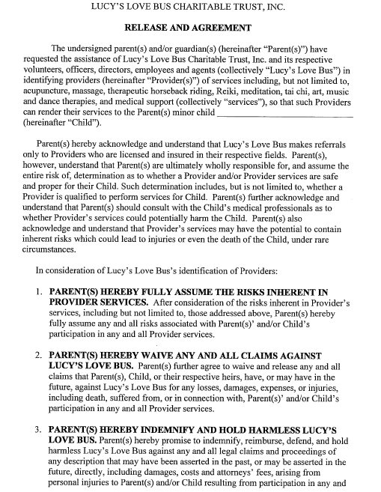
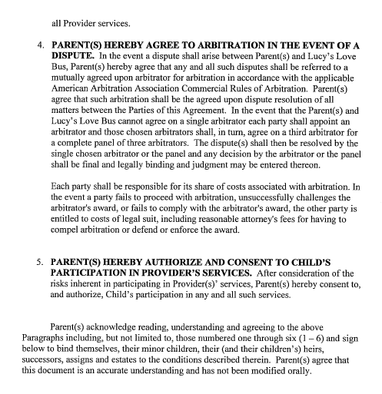

_________________________________ ____________________________________
Parent/Guardian Printed Name Parent/Guardian Signature

__________________________________
Date

Please present to your child’s oncologist or NP on their medical team; children in remission for more than one year may present to their attending physician for therapies other than those italicized below.
Lucy’s Love Bus Medical Permission Form
Dear Medical Professional,

Your patient,___________________________, has applied for a monetary grant for integrative therapies through our non-profit organization, Lucy’s Love Bus (www.LucysLoveBus.org). Prior to providing services to pediatric oncology patients, we require medical permission from the patient’s primary oncologist or nurse practitioner (or family physician for those at least one year in remission).

Please check the therapies that you approve for the above patient. Please make a note of any contraindications.

- ALL THERAPIES LISTED BELOW
- Acupuncture
- Acupressure (no needles)
- Aromatherapy/essential oils
- Art therapy or lessons
- Child life support or play therapy
- Chiropractic care
- Craniosacral/myofascial therapy
- Dance
- Fertility preservation
- Gym membership or personal training
- Gymnastics
- Martial arts
- Meditation
- Music therapy or lessons
- Naturopathy or herbal supplements
- Nutritional counseling
- Oncology massage (only from a licensed therapist with oncology certification)
- Massage (from a licensed therapist, may not have oncology OR pediatric experience)
- Reflexology
- Reiki/Tong Ren/QiGong/Other Energy Work
- Swimming/aquatic therapy
- Therapeutic horseback riding/hippotherapy
- Regular horseback riding lessons at a facility that does NOT have PATH certification
- Yoga
- Other: ________________________________

Oncologist’s signature: _____________________________ Date: ________________

Printed name:_____________________________________ Phone/email:_______________________
Please fax to: (978) 517-1567; Questions: (781) 454-8535 or Kerry@LucysLoveBus.org

